**VPC- Task**

1. Create VPC with 2 private and 2 public subnets.

Public Subnet

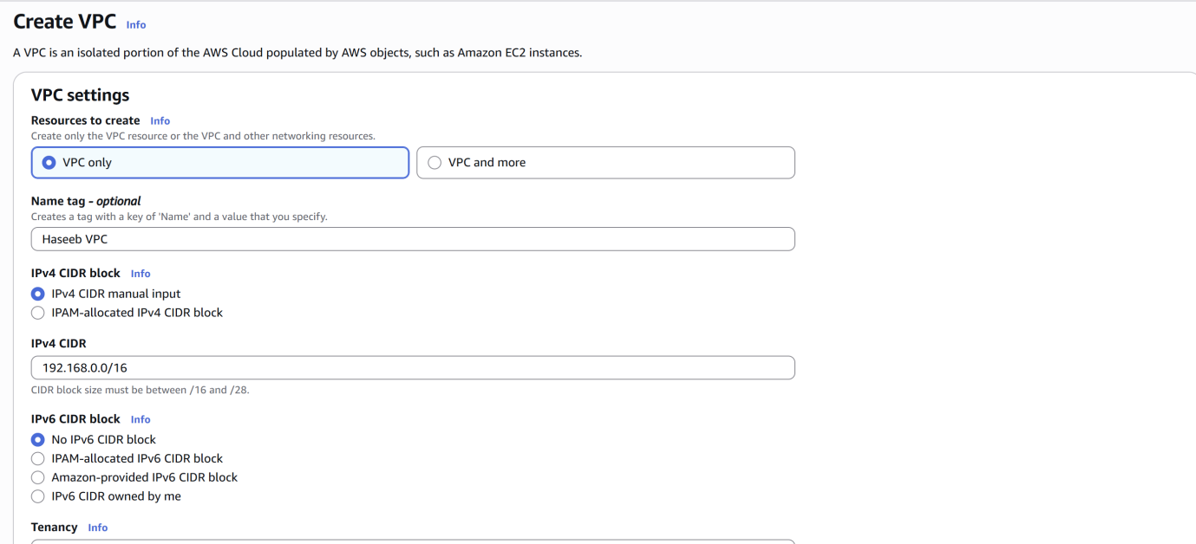

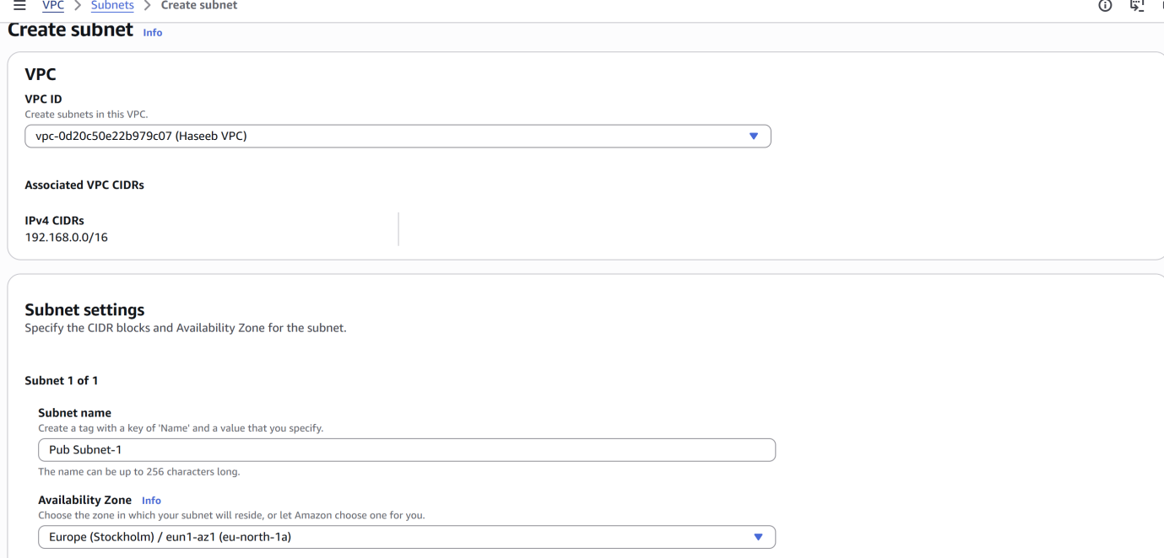

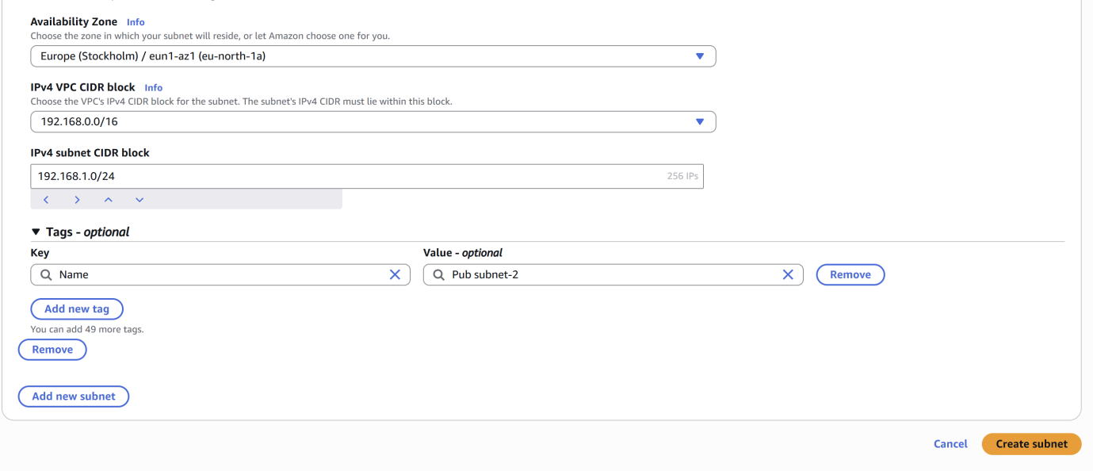

Private Subnet

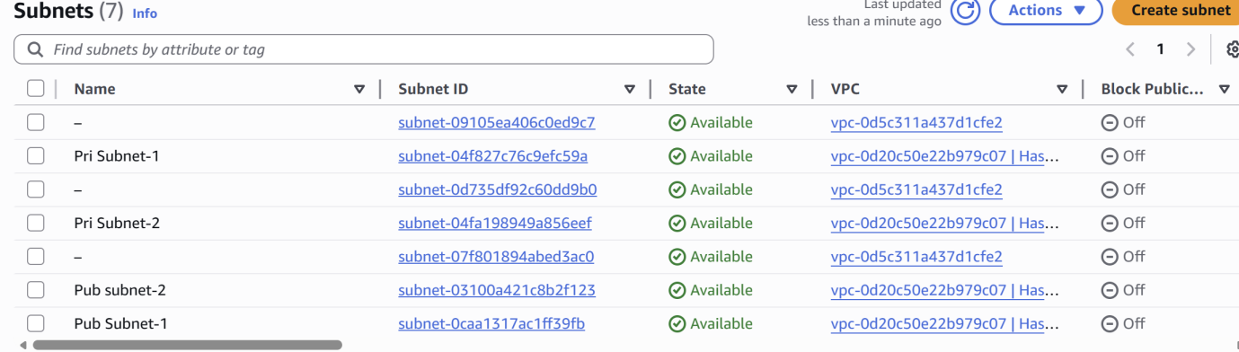

1. Enable DNS Hostname in VPC.

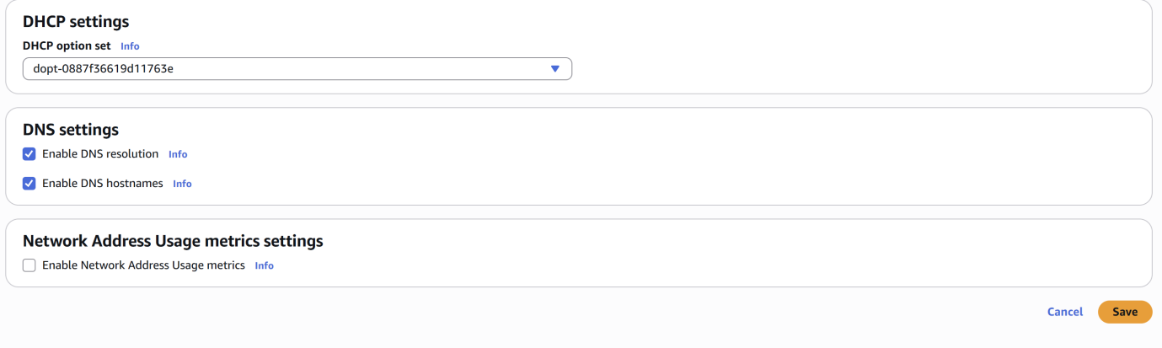

1. Enable Auto Assign Public IP in 2 public subnets.

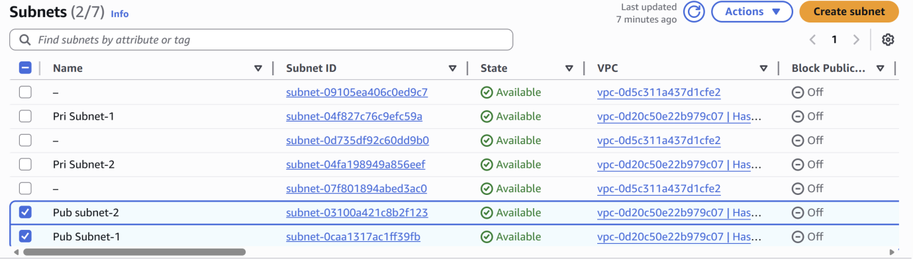

1. Add 2 private subnets in private route table.



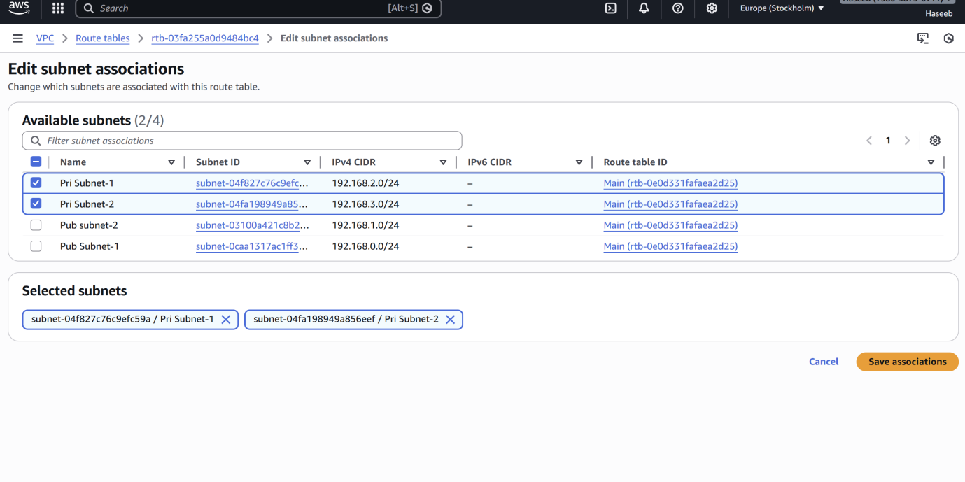

1. Add 2 public subnets in public route table.

Private Subnets

Public Subnets

1. Public route table will have the routes to internet and local.

1. Create EC2 in public subnet with t2.micro and install PHP.

1. Configure NAT gateway in public subnet and connect to private instance.

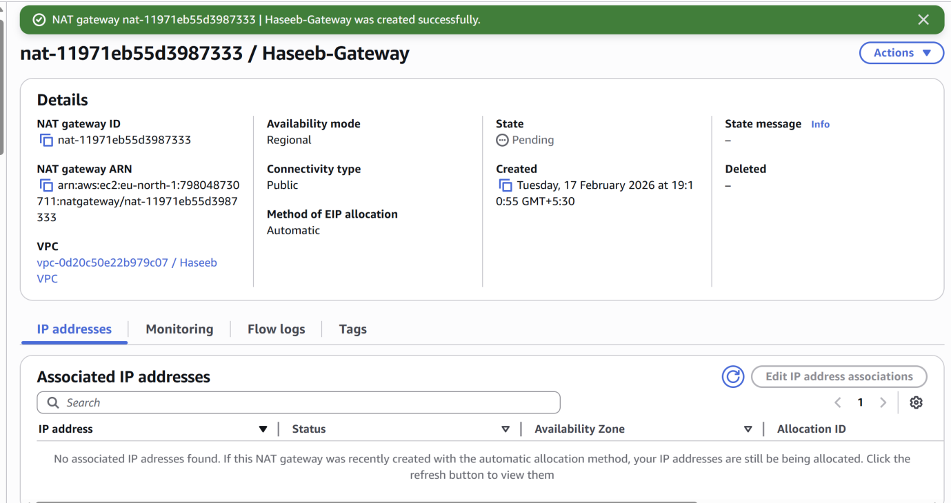



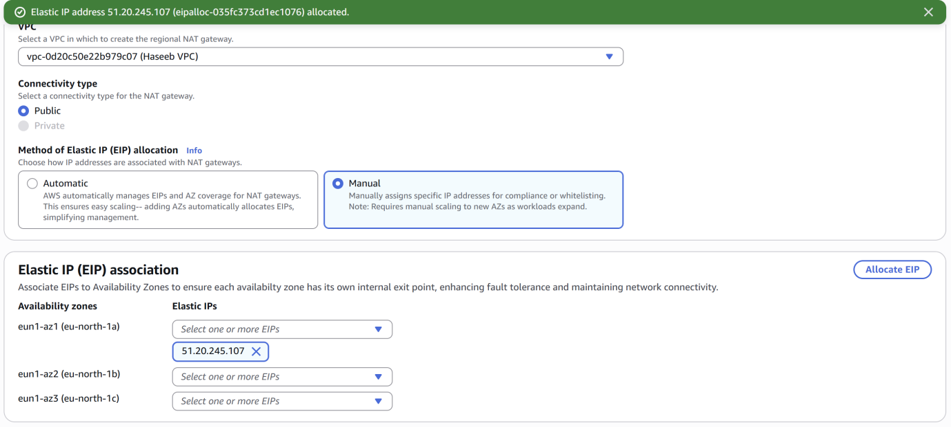

Configure VPC flow logs and store the logs in S3 and CloudWatch.

**S3**

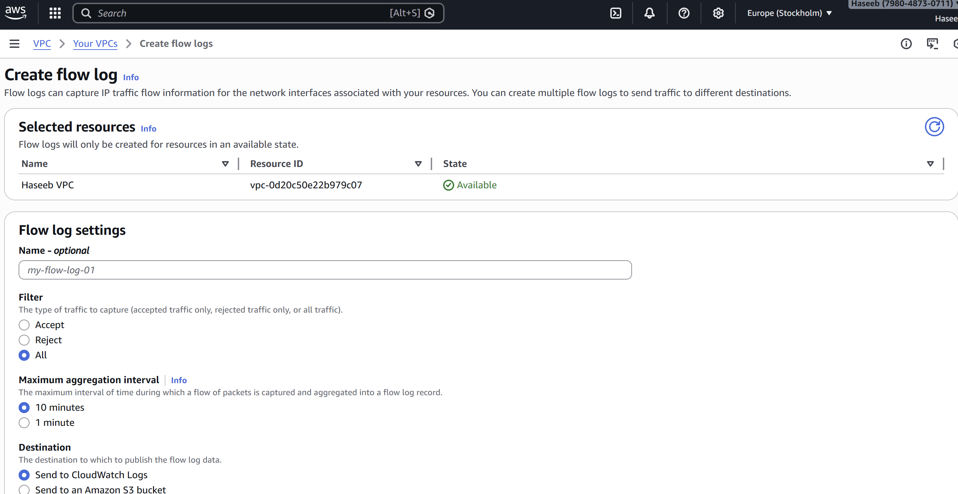

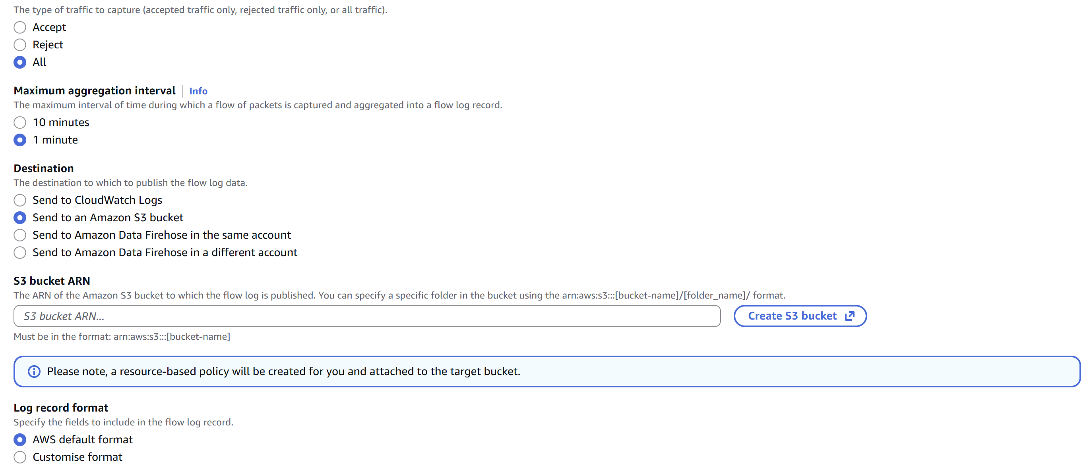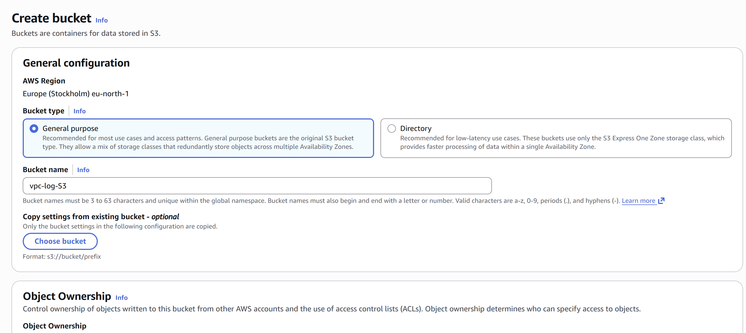

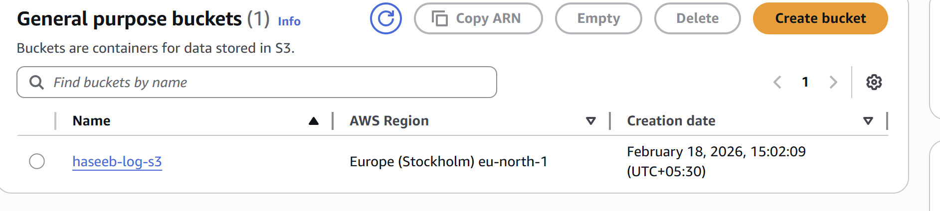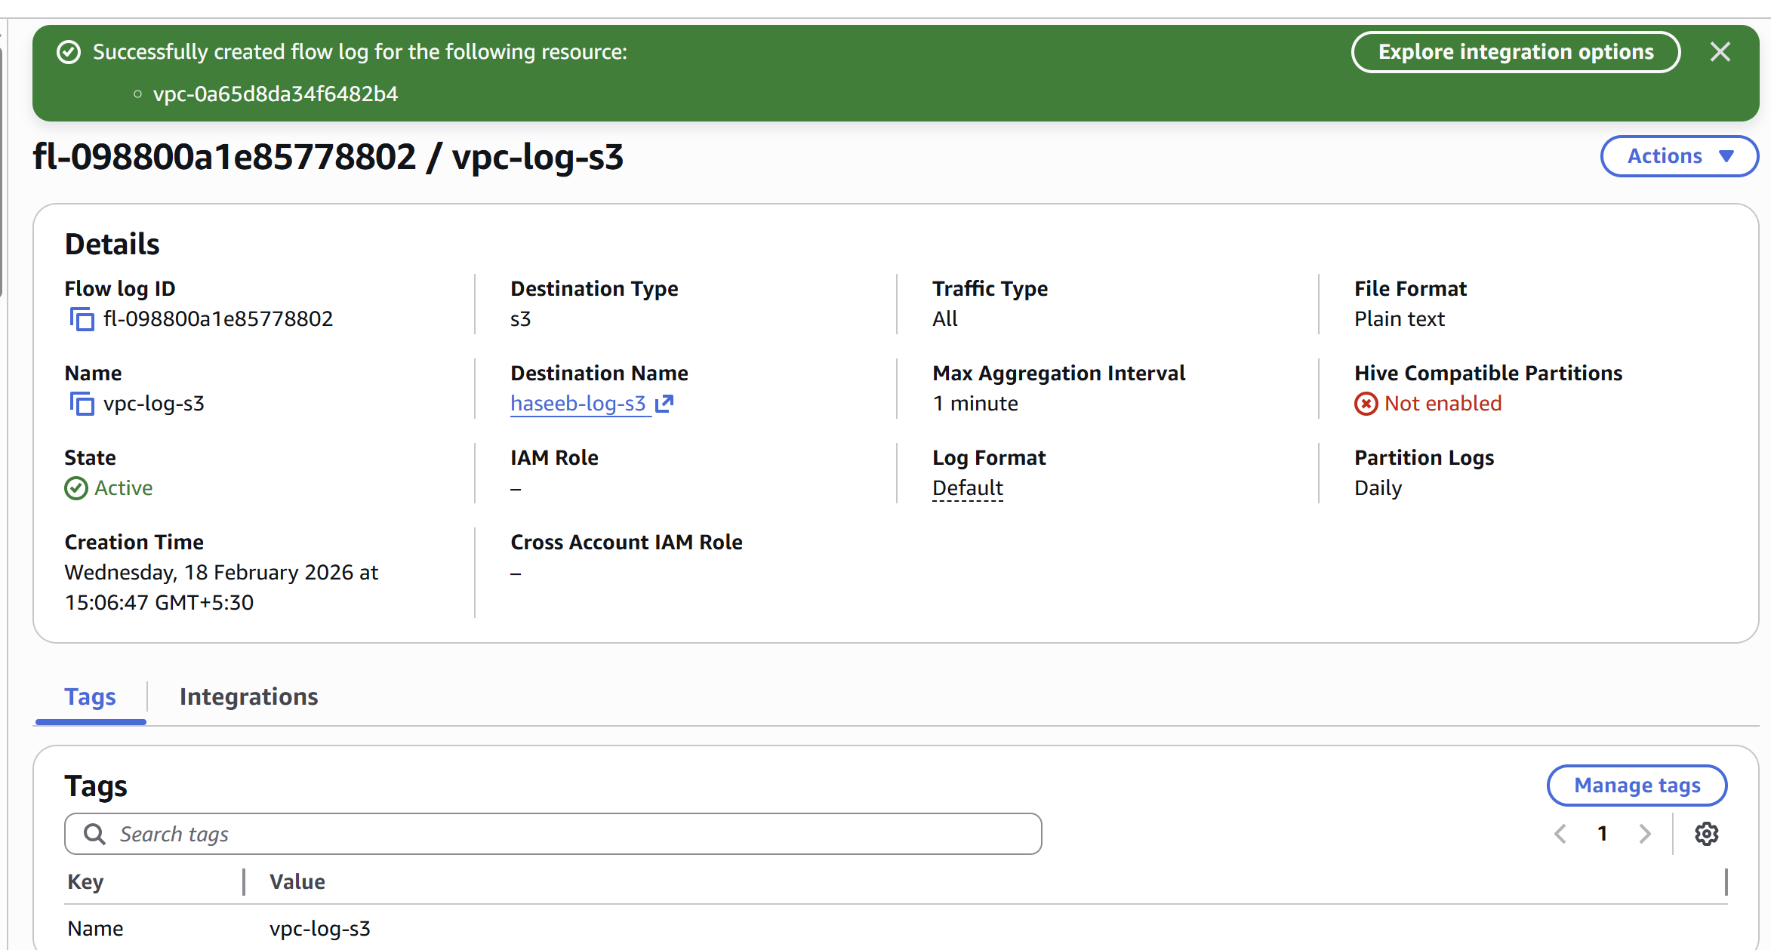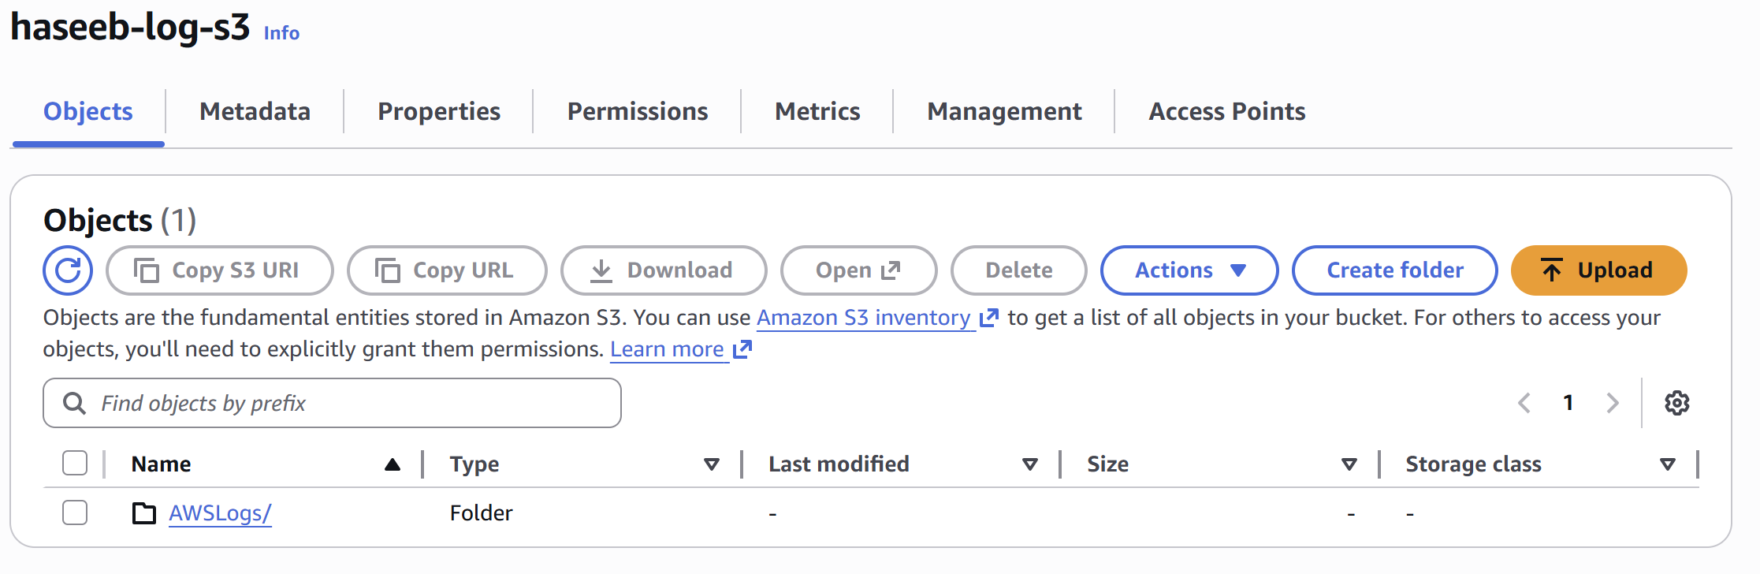

**Cloudwatch**

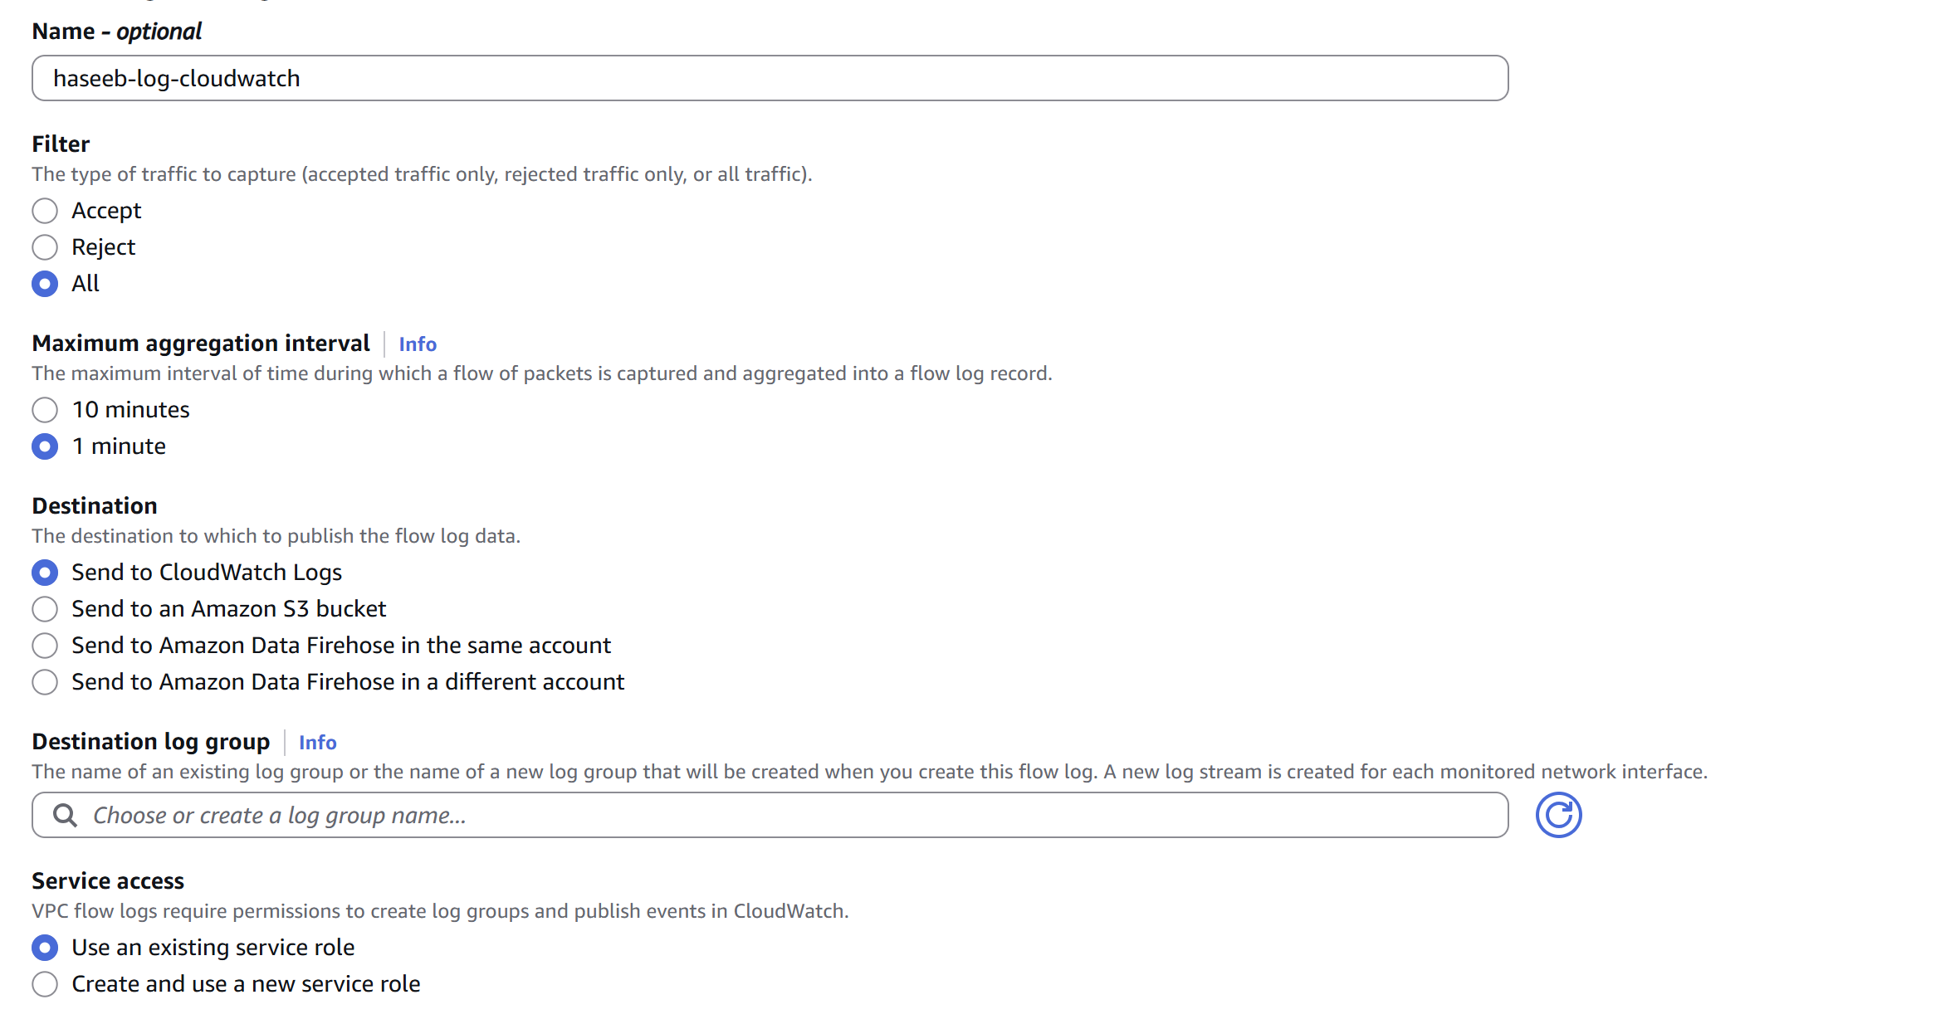

Write the destination log group name as you wish

Then need to create a policy to have a service role.

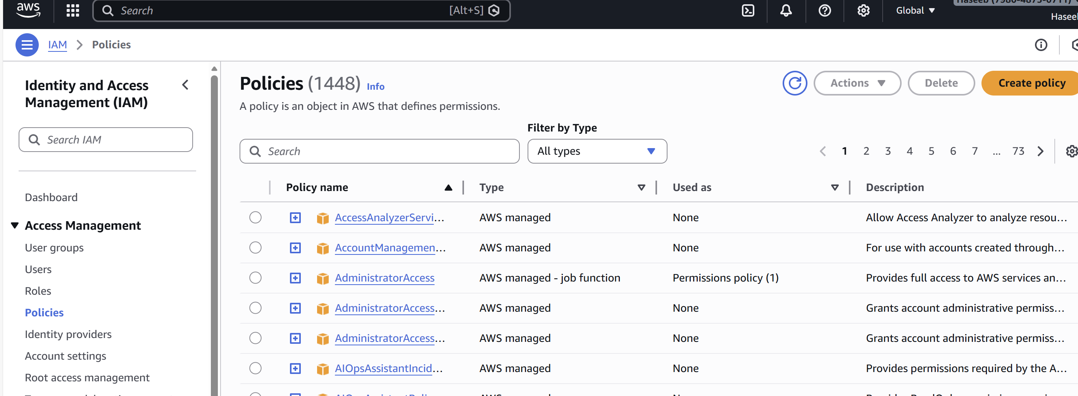then we need to search “vpc flowlogs to store in cloud watch log group” in google, cope the script and paste it in here

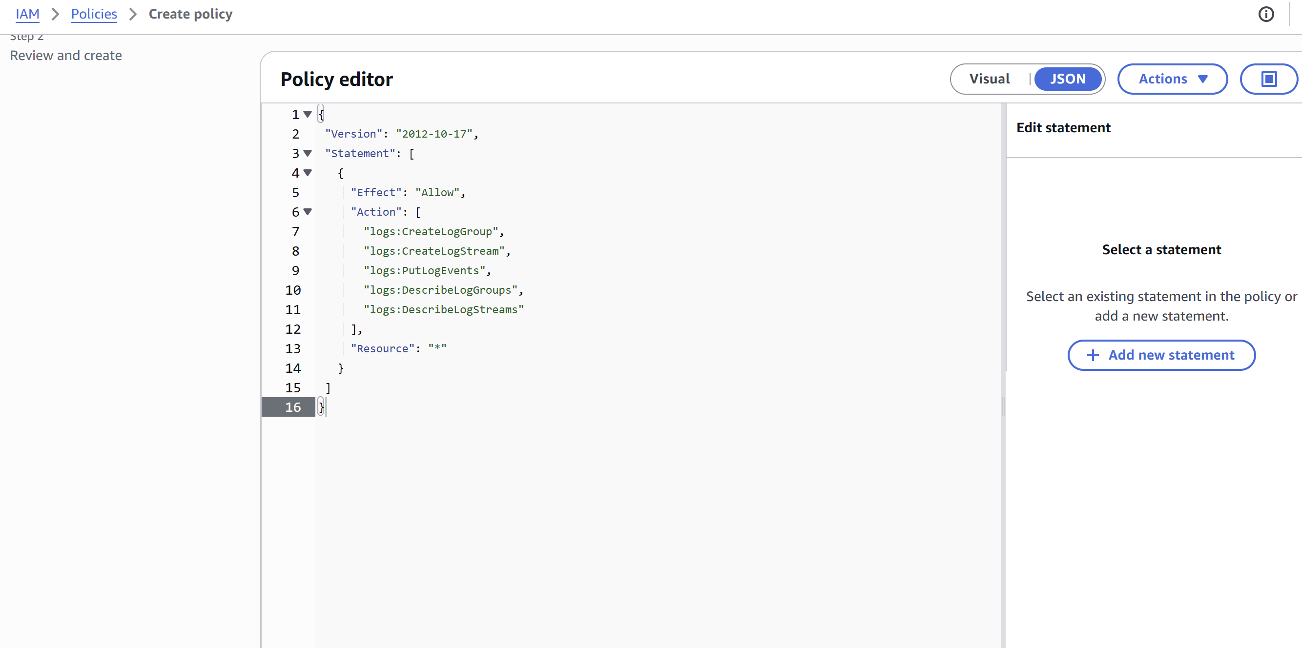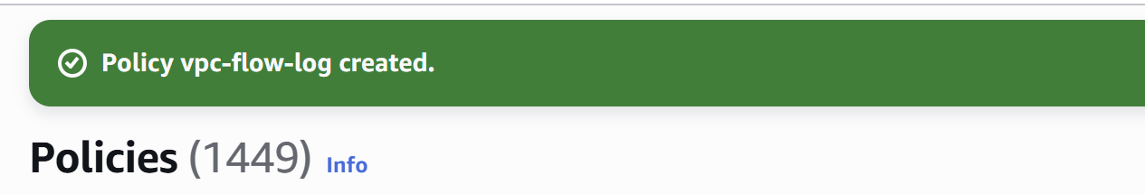

After creating a policy we can create a role based on this.

